Cookbook

# Paprikás Pasta

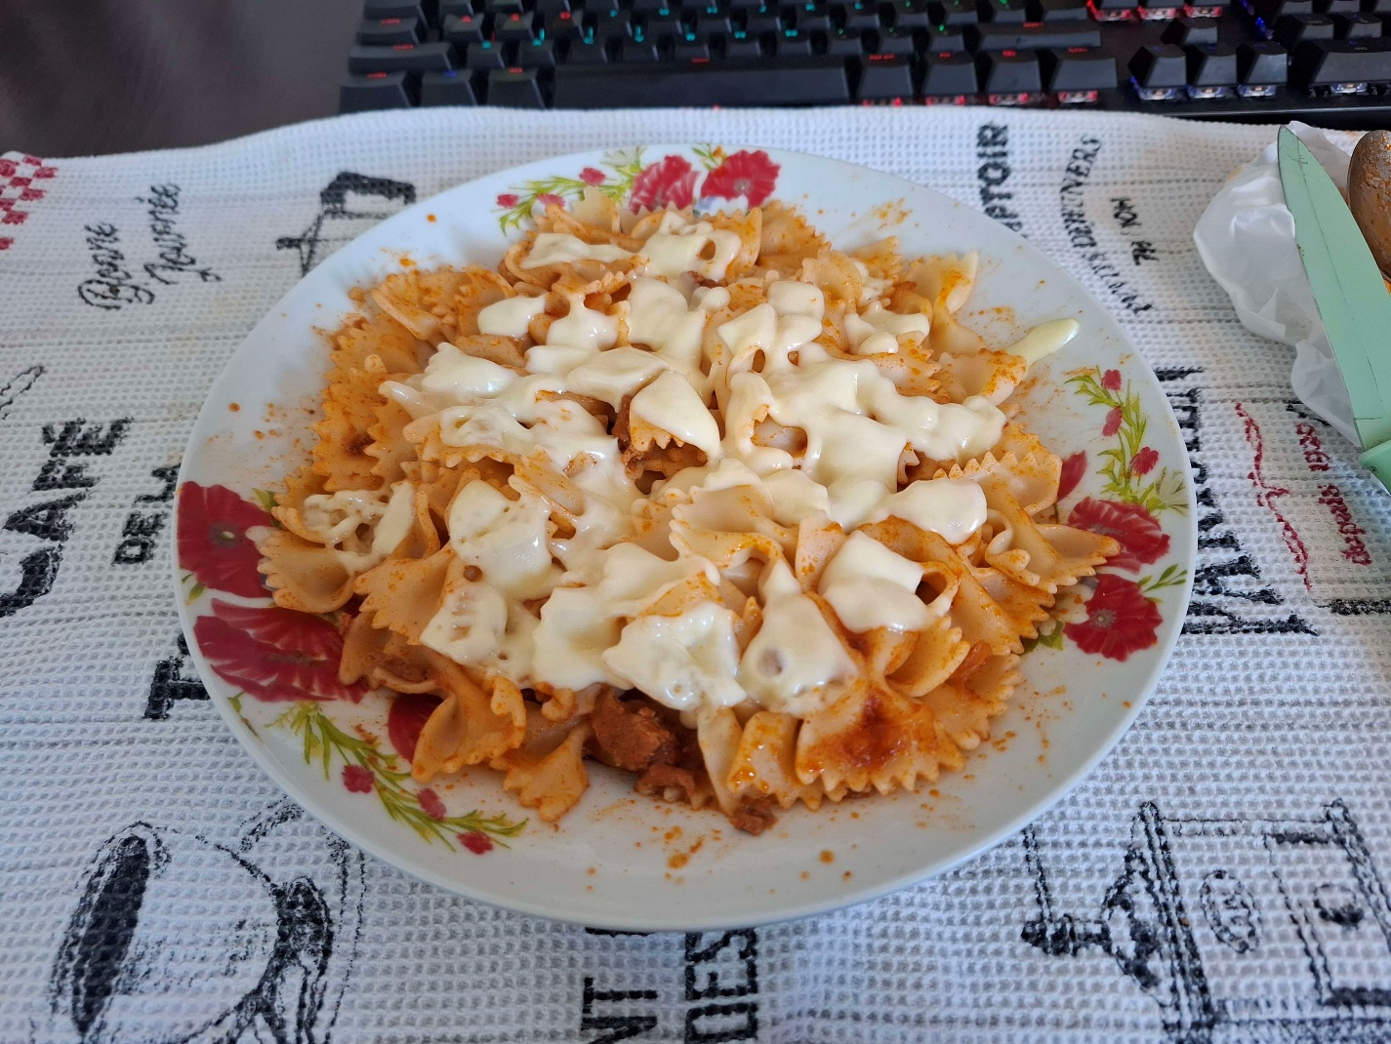

## Ingredients (4-6 servings)

* 1 onion
* 4-6 slices of meat (I used boneless pork meat)
* 1 small can of tomato concentrate
* 1 small jar of sliced mushrooms (optional based on taste)
* Cheese (optional but mandatory)
* Pickles (optional as a side)
* Water
* Oil
* Sweet paprika powder
* Salt
* Pasta (any type of pasta)

## Preparation (1.5 hours)

* Cut the onion into small slices and put it inside the pot with a little bit of oil, just enough to cover the bottom of the pot. Let it cook for 10 minutes and keep stirring each minute. While it cooks cut the meat into small cubes
* After the 10 minutes have passed add the meat on top of the onion and let it cook for another 15 minutes while stirring every minute
* After the 15 minutes have passed add 3 small spoons of sweet paprika powder and the small can of tomato concentrate and stir them very good so they mix (this shouldn’t take longer than 1 minute). After this quickly add 1,5-2L of water and a small jar of sliced mushrooms if you like mushrooms. Let it boil for approximately 1 hour or until the water level is only 2 fingers
* While the meat is boiling you can put the pasta in another pot, just add some water, salt and pasta and mix it and leave it for 15 minutes to boil and after drain the water.
* When you want to eat mix the sauce with the pasta and I recommend adding some cheese on top also and pickles on the side, that way it tastes better

## Pictures of the process and finished product

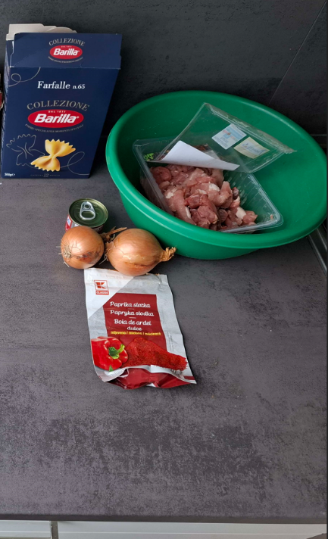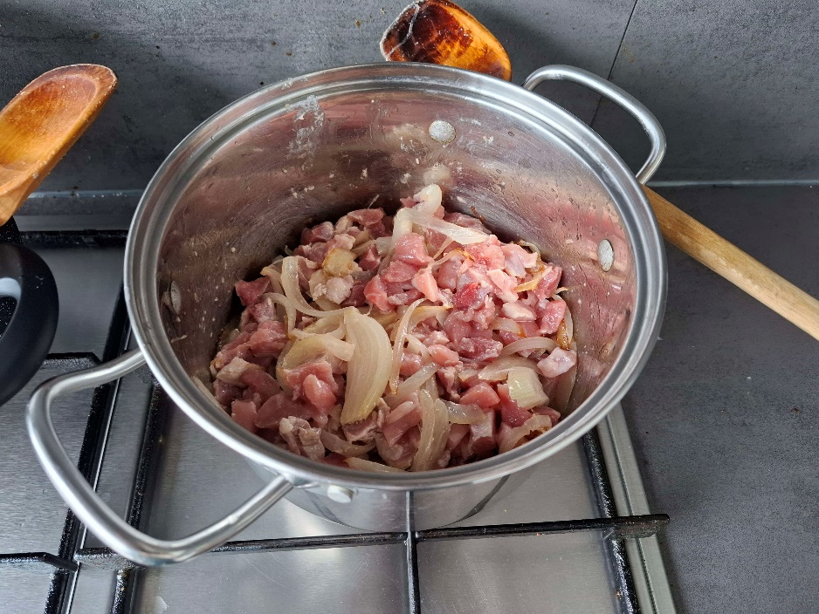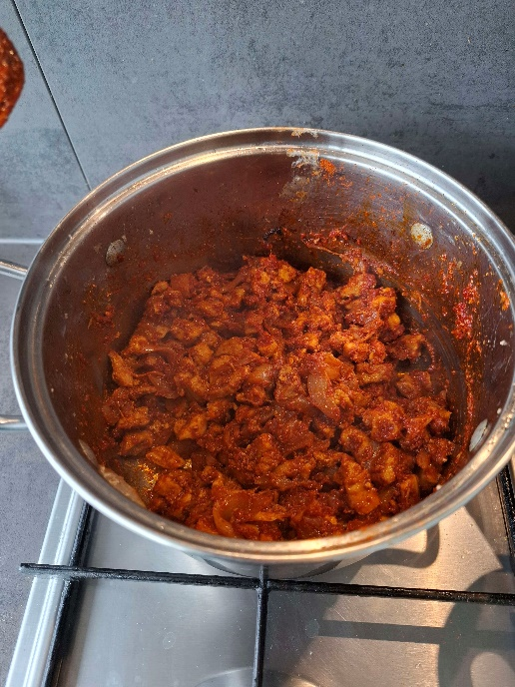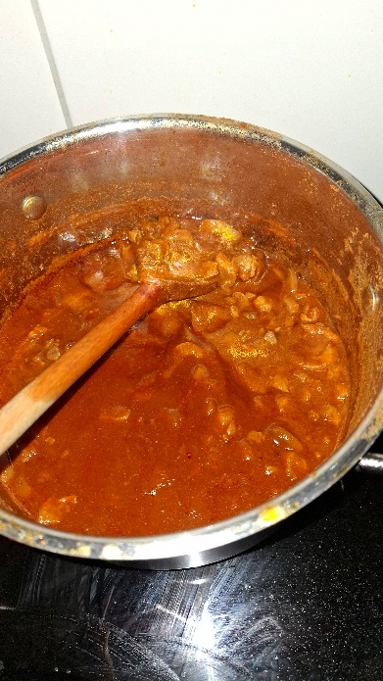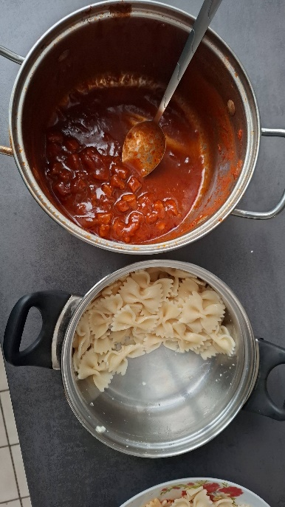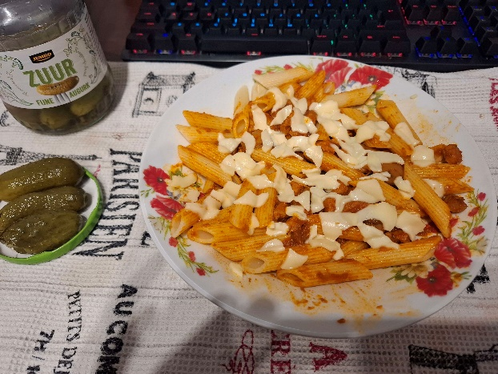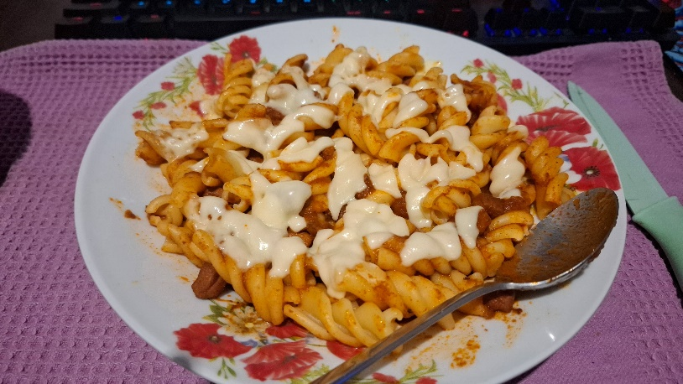

# Egg soup

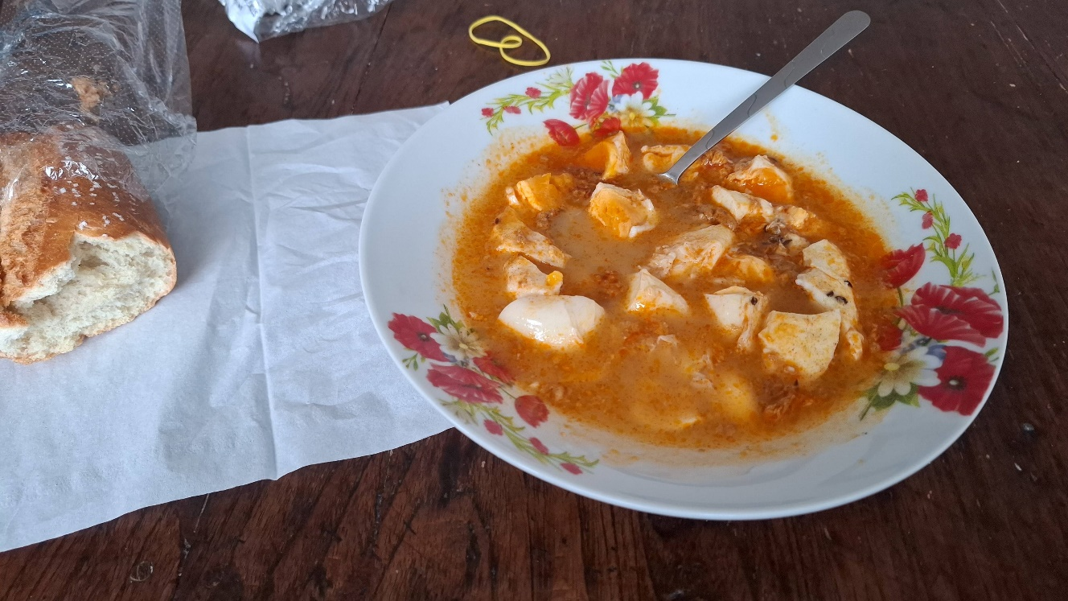

## Ingredients (4 servings)

* 12 eggs
* Oil
* Caraway seeds
* Sweet paprika powder
* Salt
* Water
* Bread

## Preparation (15 minutes)

* In a pot put a little bit of oil just enough to cover the bottom. Add half a small spoon of caraway seeds and half a small spoon of sweet paprika powder and let them fry for 20-30 seconds while you mix them. After quickly add 1L of water and a small spoon of salt
* When the water starts to boil crack the eggs and add them inside the pot. Let them boil based on preference: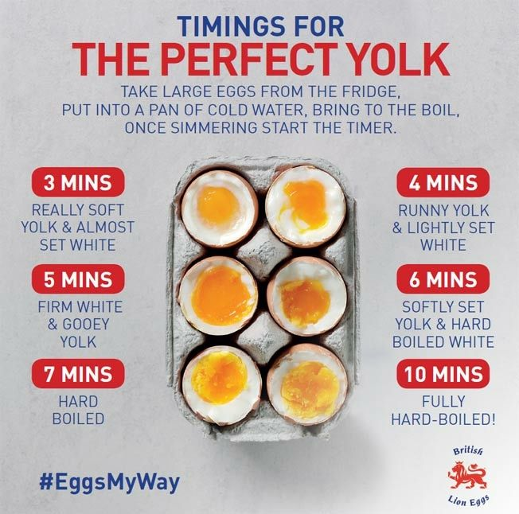
* After that toast some bread and serve the soup in a dish (usually 3 eggs for a serving)

# Chicken liver food

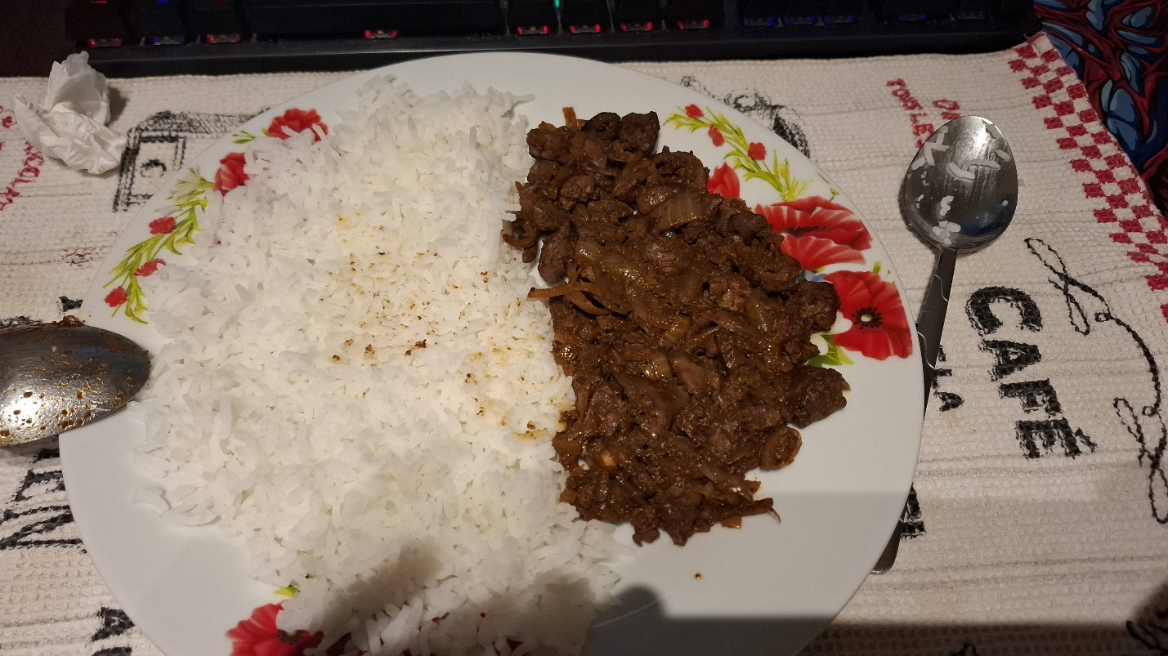

## Ingredients (4 servings)

* 400g of chicken liver
* 2 onions
* Oil
* Pickles (optional side)
* Sweet paprika powder
* Water
* Salt (Very important! Only add the salt right before you’re eating, don’t add it into the whole mixture, the liver gets very dry if you put salt on it after an hour)
* Rice

## Preparation (30 minutes)

* Cut the 2 onions into small slices and cook them in oil for about 5 minutes in a pan. Cut the liver into small slices while the onion is cooking
* Add the liver on top of the onions and after 5 minutes add some sweet paprika powder on top, 2 small spoons. Quickly after add 100ml of water and let it boil for about 15 minutes
* While the liver is boiling make the rice in a different pot, just add some water, salt and rice and let it boil for about 15 minutes and after drain the water
* When they are both ready you can put them on a plate and add the salt on top of the liver and mix with a lot of salt. It is very good with some pickles on the side

## Pictures of the process and finished product

# Chicken soup

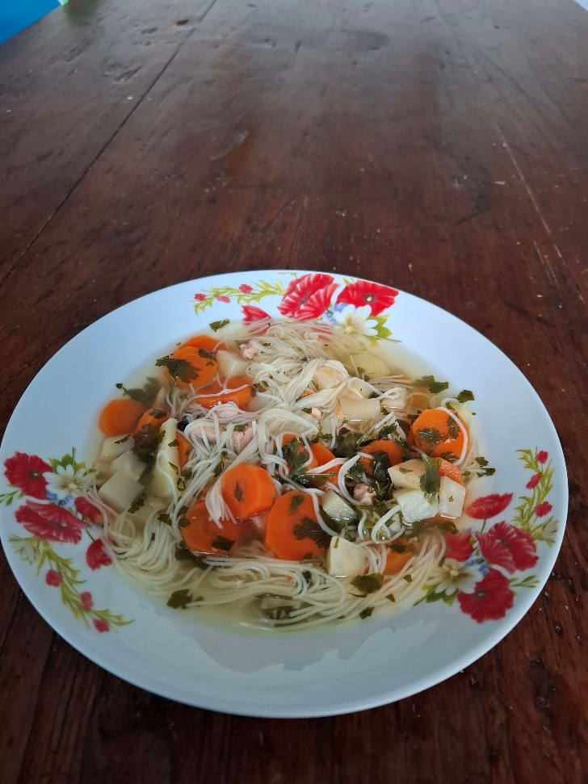

## Ingredients (8-10 servings)

* Chicken or turkey meat (2 slices)
* 4 carrots
* 2 parsleys or parsnips root
* 20g of parsley leaves
* 1 celery
* 3 small spoons of Vegeta
* 6 pepper balls
* Water
* noodles

## Preparation (1.5 hours)

* Cut everything into small pieces while the water starts boiling
* Add everything inside the boiling water all at once except the noodles and the parsley leaves
* Let it boil for 1 hour and after that add the noodles and the fine cut parsley leaves and let it boil for another 12 minutes and after that it’s ready to serve

## Pictures of the process and finished product

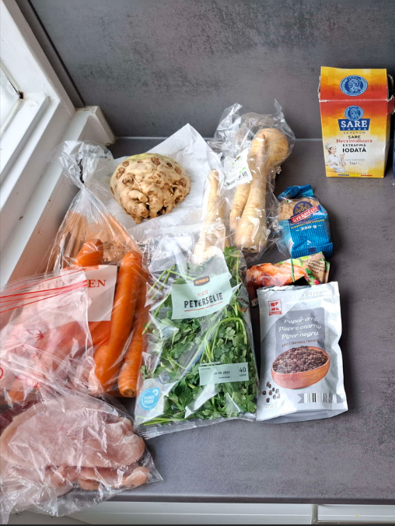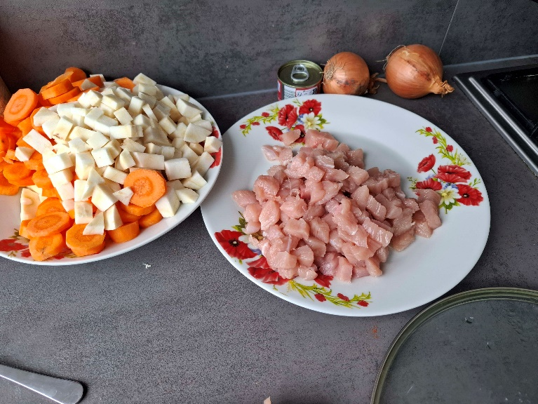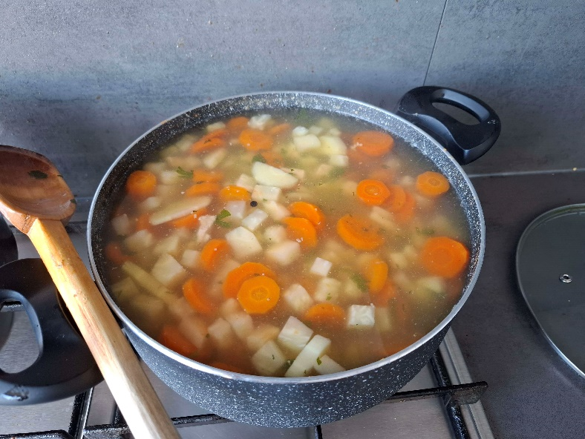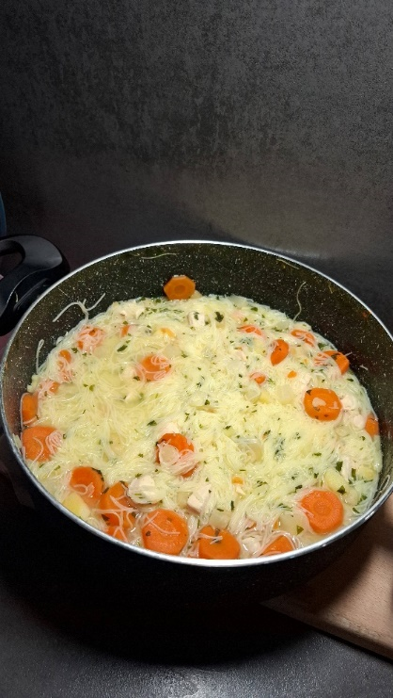

# Meatball soup

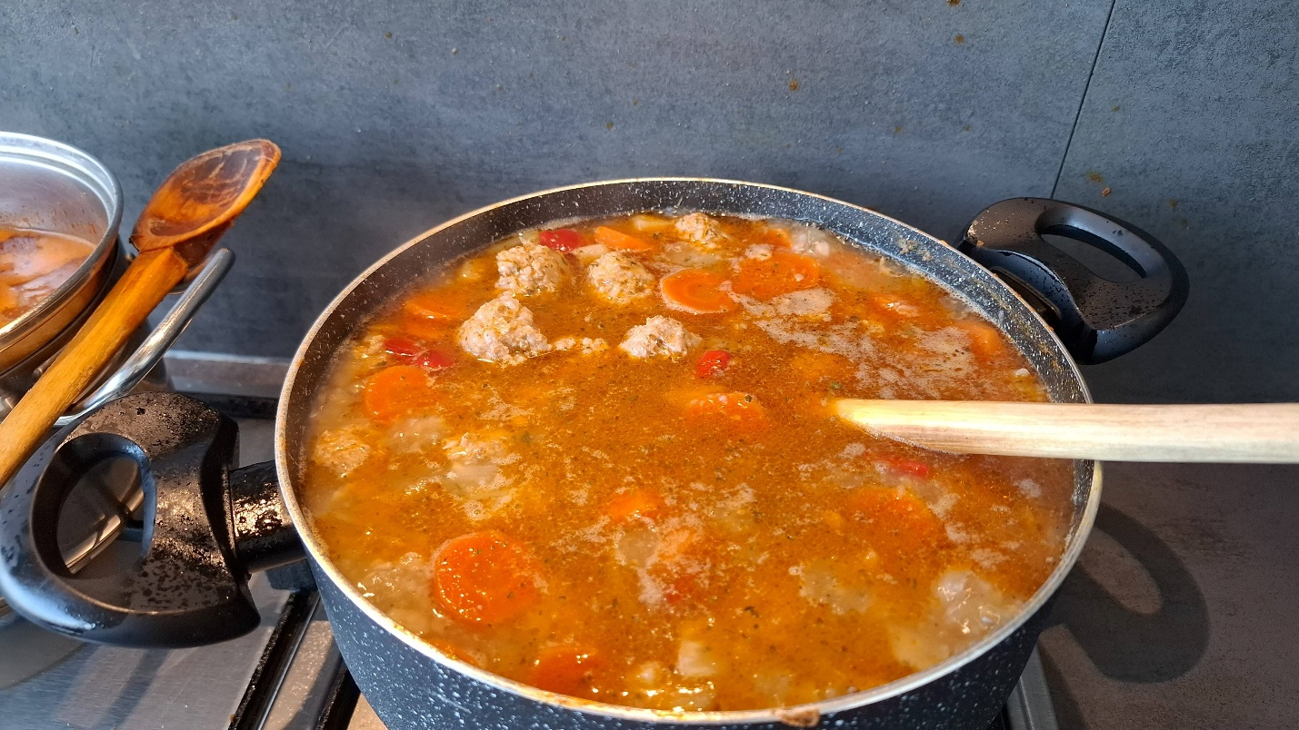

## Ingredients (8 servings)

* 500g of minced meat
* 4 carrots
* 2 parsleys or parsnips root
* 1 onion
* 1 paprika
* 2 potatoes
* Salt
* Pepper
* Water
* Powder thyme
* Sweet paprika powder
* Rice
* 2 eggs

## Preparation (1.5 hours)

* Cut all the vegetables into small cubes and put them inside a pot with a little bit of oil and let them cook for 15 minutes while mixing every minute
* Add 1 small spoon of sweet paprika powder and quickly after 2L of water. After, add 2 small spoons of salt and half a small spoon of pepper
* While you let the water boil make the meatballs: mix 500g of minced meat together with 100g of rice, 1 small spoon of salt, 1 small spoon of powder thyme and 2 eggs. After they are mixed together very well start making small balls out of the mixture.
* When the water starts to boil add the meatballs inside the soup and let them boil for another 45 minutes
* After that add 2 potatoes cut into small cubes and let it boil for another 15 minutes and it’s ready to serve

## Pictures of the process and finished product



# Potato soup

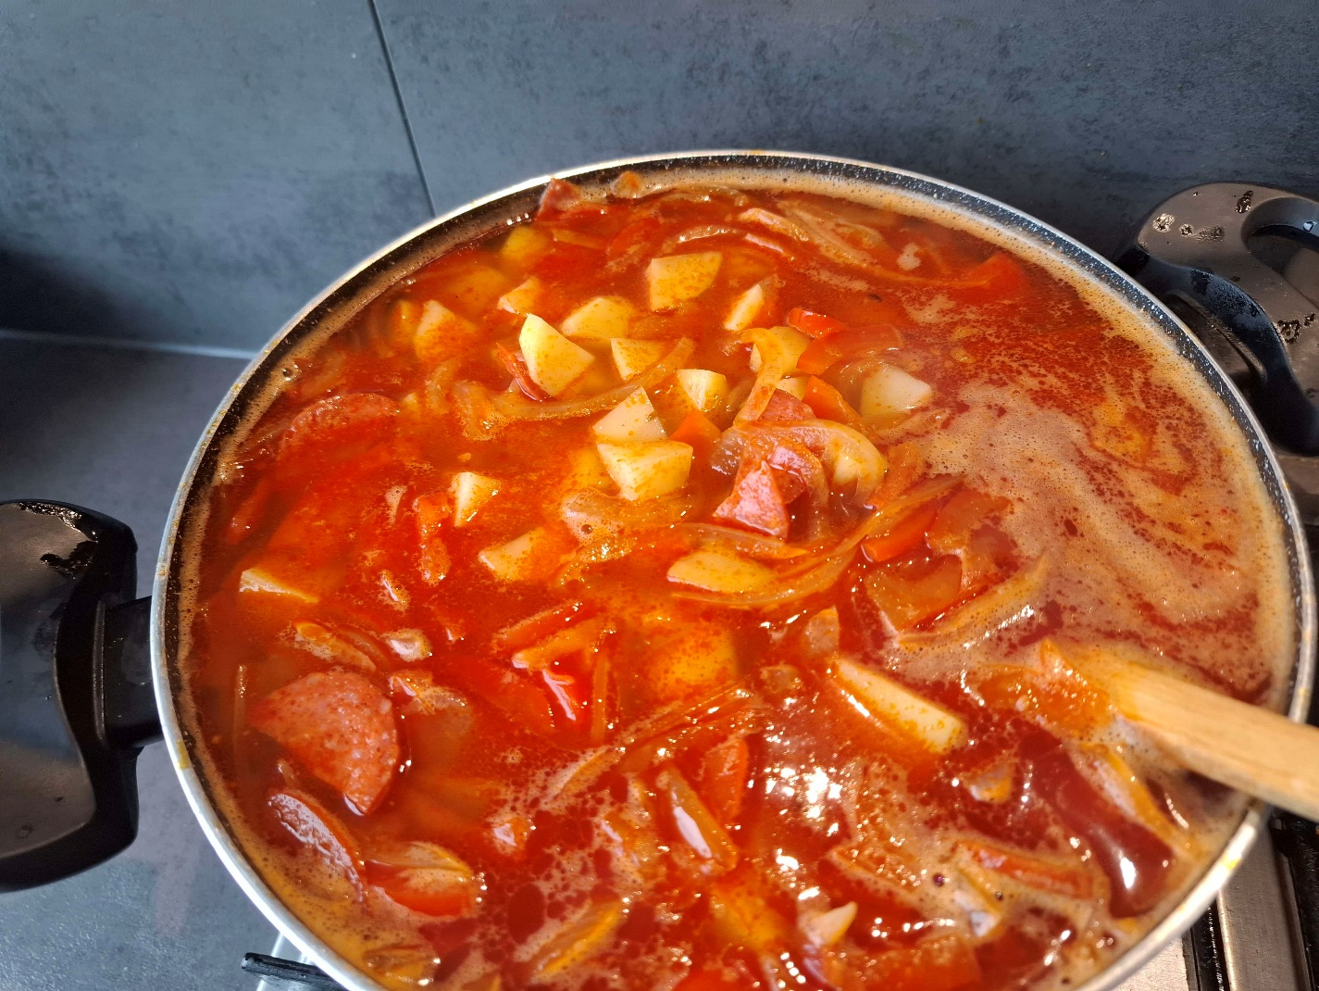

## Ingredients (8 servings)

* 1,5-2kg of potatoes
* 1 onion
* 1 paprika
* Sweet paprika powder
* Water
* Salt
* 100g-125g Smoked sausage

## Preparation (1 hour)

* Put a little bit of oil inside a pot just to cover the bottom and cut the onion and paprika into small slices and add them inside the pot and let them cook for about 5 minutes
* Add a spoon of sweet paprika powder and 2 spoons of salt and 2L of water. Cut the potatoes into small cubes and the smoked sausage into small slices
* After the water starts to boil add the potatoes and the smokes sausage inside the pot and let them boil for about 30 minutes. After that the soup is ready to be served

## Pictures of the process and finished product



# Meat steak

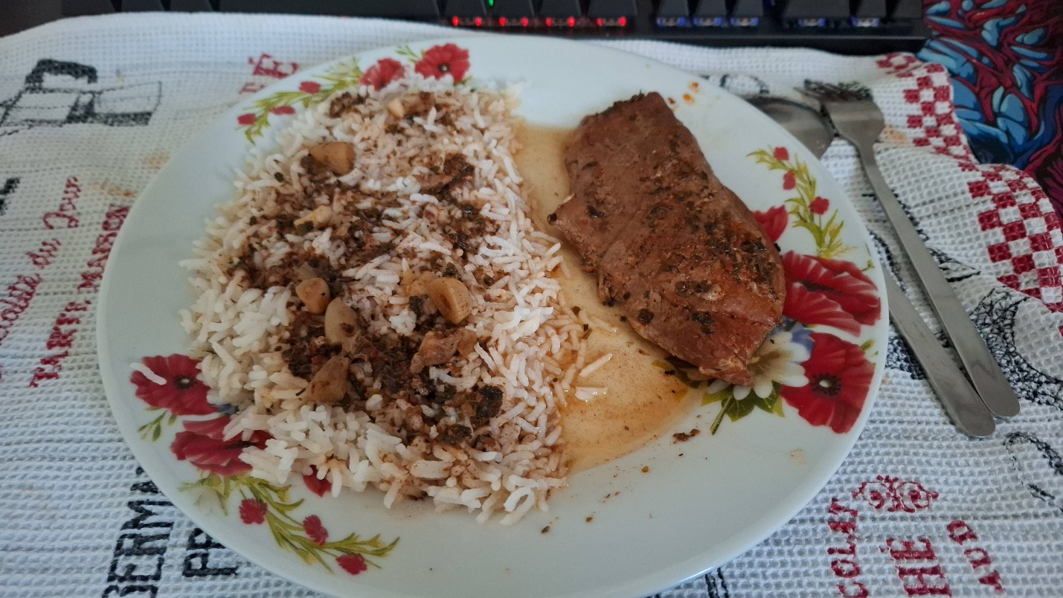

## Ingredients (4 servings)

* 4 slices of meat
* Rice
* Pickles (optional side)
* Garlic
* Oil
* Salt
* Sweet paprika powder
* Thyme
* Basil
* Oregano

## Preparation (2 hours)

* Put inside a pot a little bit of oil just to cover the bottom and add the slices of meat. Put some salt on top of the meat and let it cook for 3 minutes and after turn it on the other side add salt on top of the meat and let it cook for another 3 minutes. Add 2-3 small spoons of sweet paprika, 1 small spoon of thyme, 1 small spoon of basil and 1 small spoon of oregano. After this add 2L of water and let it boil for 1 hour and a half
* While the meat is boiling, make some rice and when it’s done serve them together. It is good with pickles on the side

## Pictures of the process and finished product

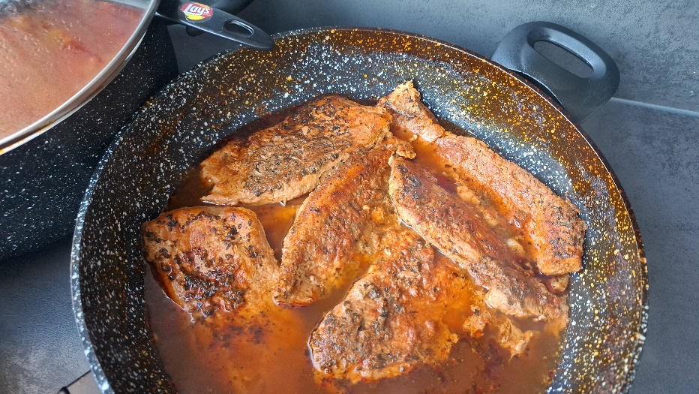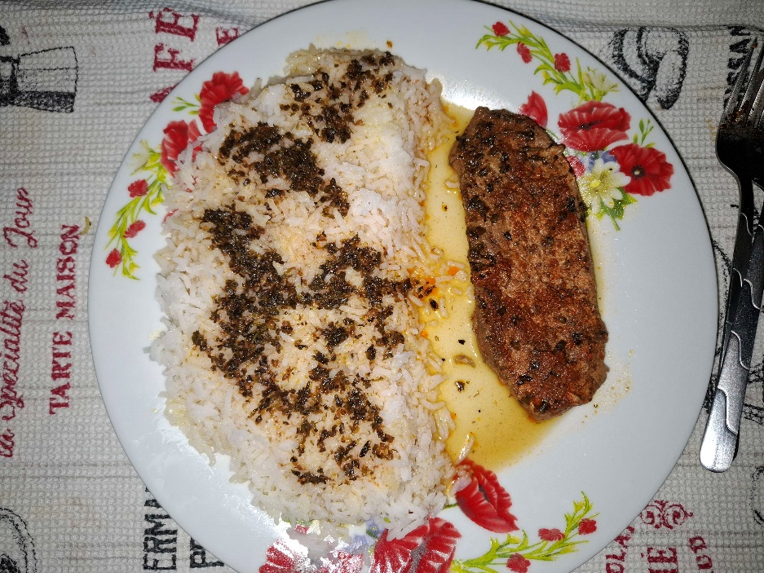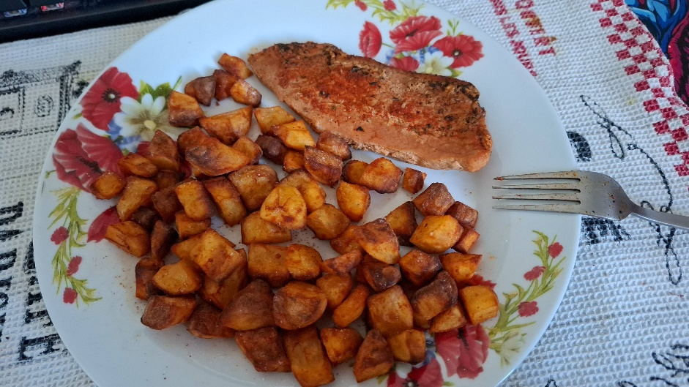

# Bechinalt soup

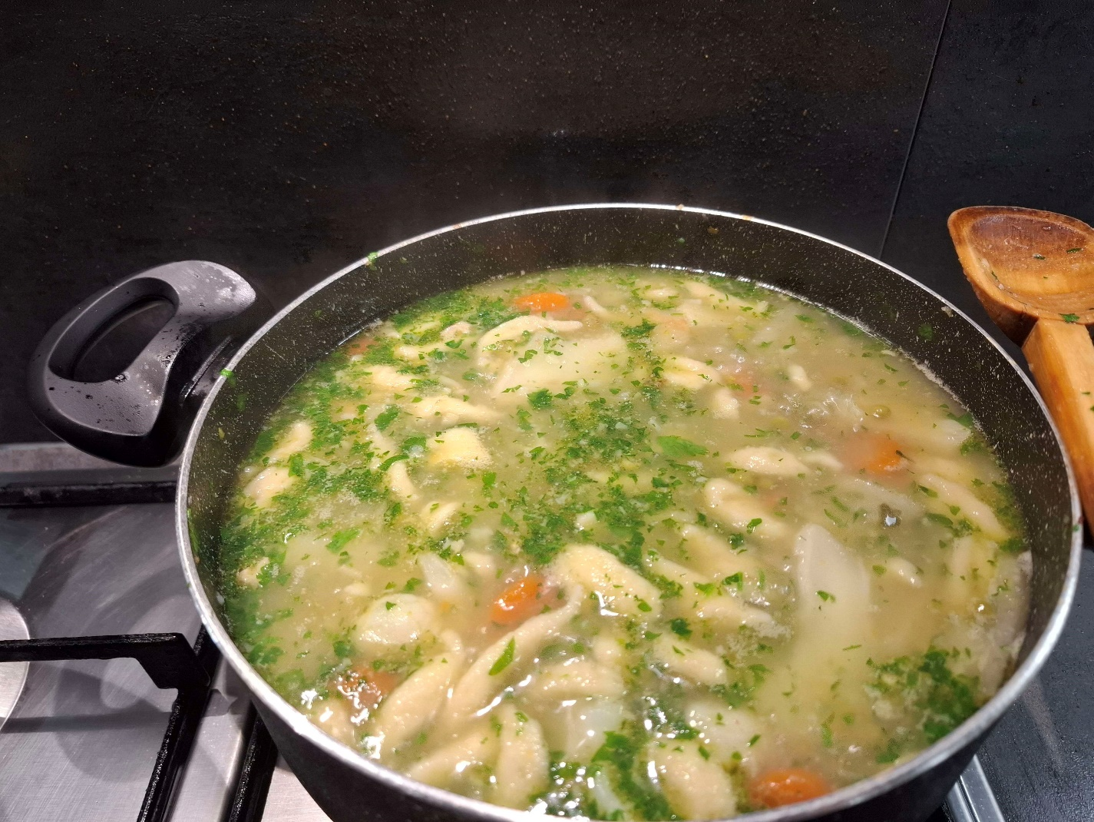

## Ingredients (8 servings)

* 2 slices of chicken or pork meat
* 1 onion
* 2 carrots
* 1 parsley or parsnip root
* 1 kohlrabi
* 1 cauliflower
* 1 jar of green peas
* Salt
* 1 egg
* 100g flower
* 15g parsley leaves (optional)
* Sour cream

## Preparation (1.5 hours)

* Cut the meat and the vegetables into small slices/cubes
* Put the meat and the vegetables inside the pot with a little bit of oil and let them cook for about 15 minutes. After that add 2L of water and let them boil for another hour. While it is boiling make the flower dumplings
* For the flower dumplings add inside a plate 1 egg with half a spoon of salt on top and mix it well. Keep adding 1 small spoon of flower on top and mixing until it’s consistency it’s like slime
* After the soup boiled for 1 hour add the flower dumplings inside the soup, from the plate of the mixture use a big spoon to cut them into small strings like dumplings and add them inside the soup.
* After add the jar of peas and the kohlrabi. Let it boil for another half an hour
* In the last 5 minutes parsley leaves can be added
* After that the soup is ready and when it’s served sour cream can be added into the plate or lemon juice to make it sour

## Pictures of the process and finished product

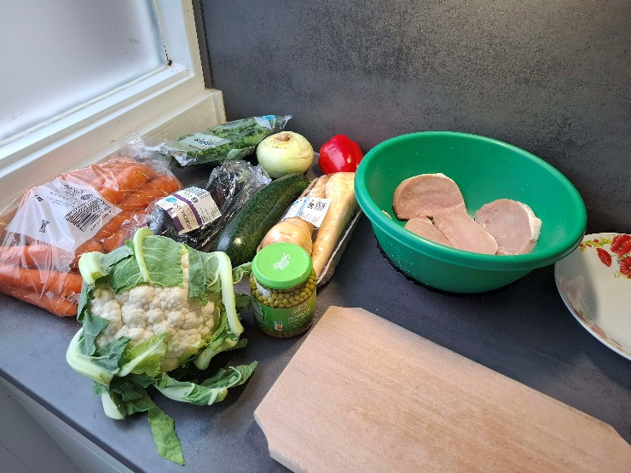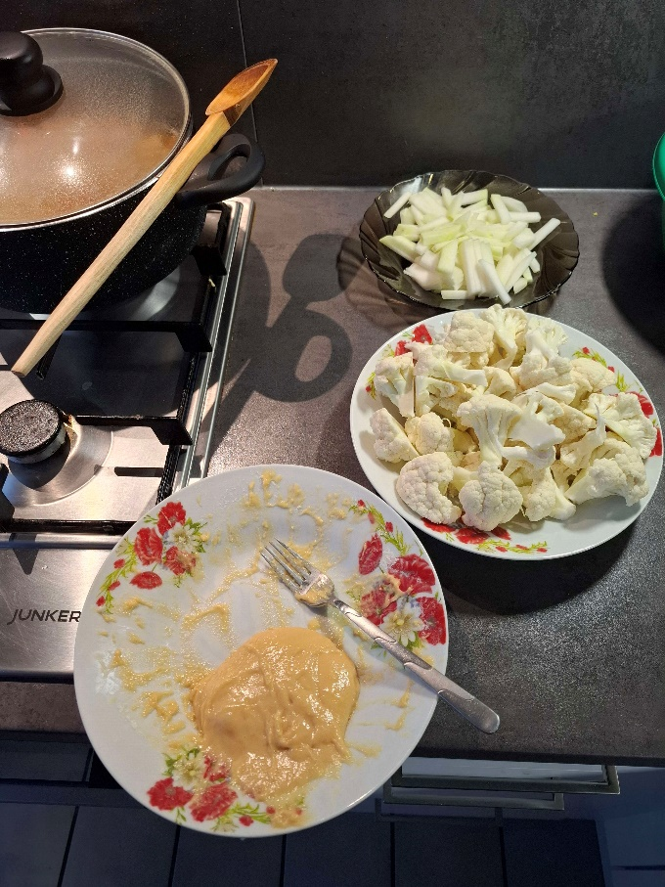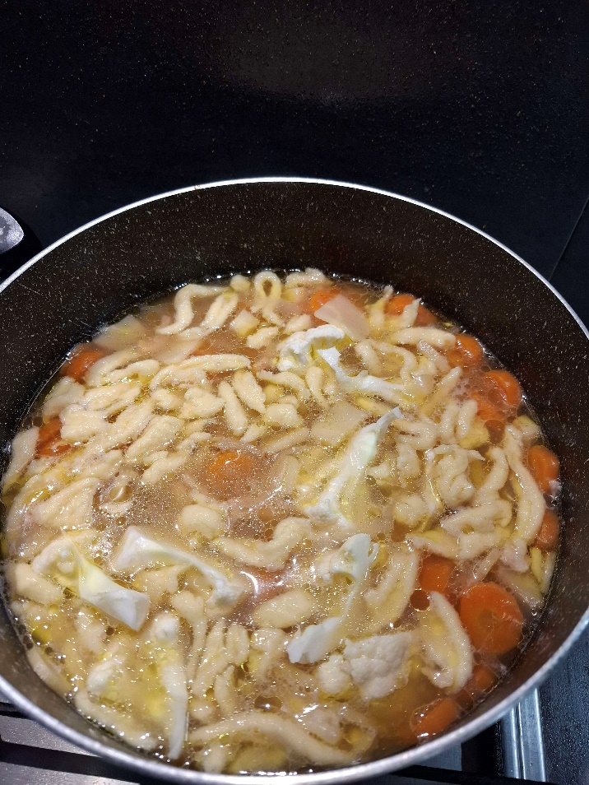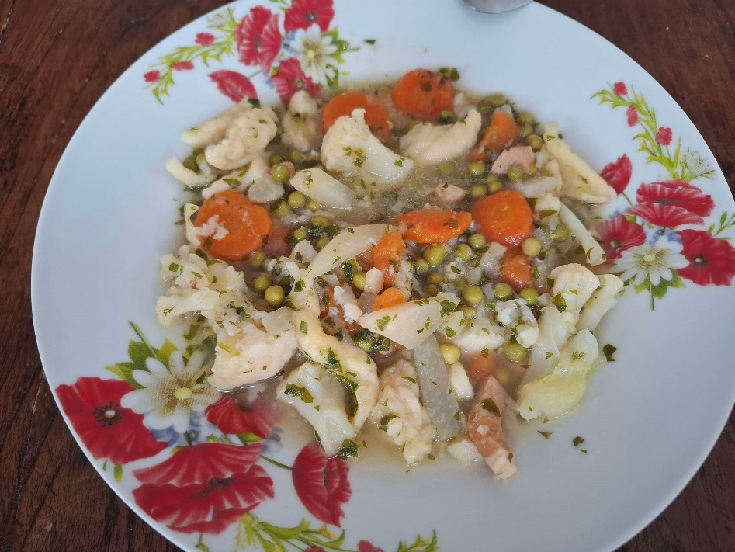

# Chinese food

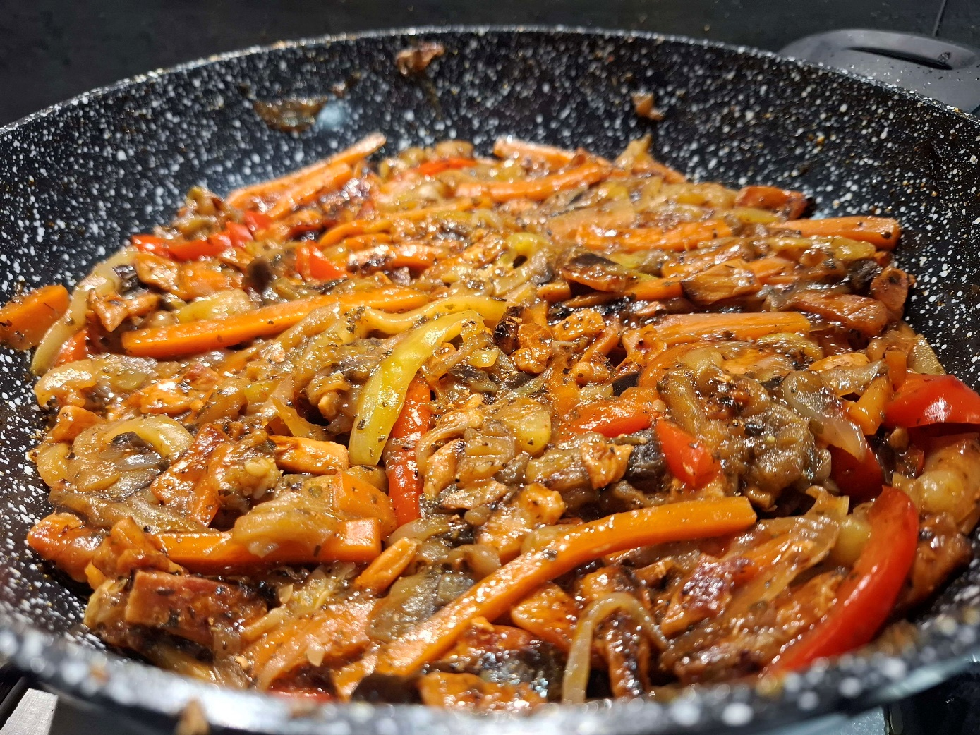

## Ingredients (4 servings)

* 4 slices of chicken or pork meat
* 1 eggplant
* 1 zucchini
* 3 carrots
* 1 paprika
* 2 onions
* Hot chili sauce
* 1 can of mushrooms (optional)
* Basil
* Thyme
* Oregano
* Rice

## Preparation (1.5 hours)

* Cut all the vegetables into small slices and the meat into cubes
* Put some oil on the bottom of a pan and put the meat cubes and let them cook for around 10 minutes. After that add hot chili sauce on top so it covers the meat and let it boil for about 50 minutes
* In another pot put some oil on the bottom and cook the onion and the carrots for about 10 minutes. After that add the eggplant, the zucchini and the paprika (and mushrooms if you like). Also add all the condiments, 1 small spoon of each basil, thyme and oregano. Let the vegetables cook for another 15 minutes and after add hot chili sauce until you cover them and let them boil for another 30 minutes.
* After they are both ready mix them together and cook them for another 10 minutes until almost all the water/chili sauce evaporates. After that it’s ready to serve alone or mixed with rice (I recommend mixing it with rice it’s way better)

## Pictures of the process and finished product

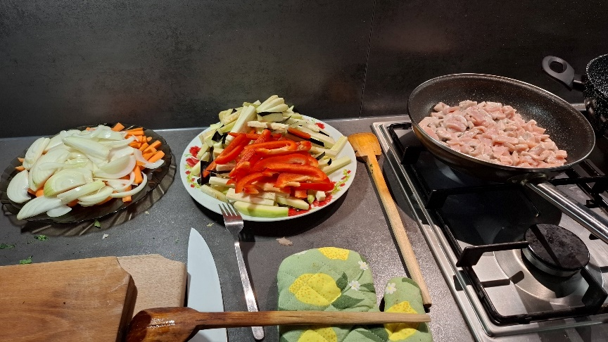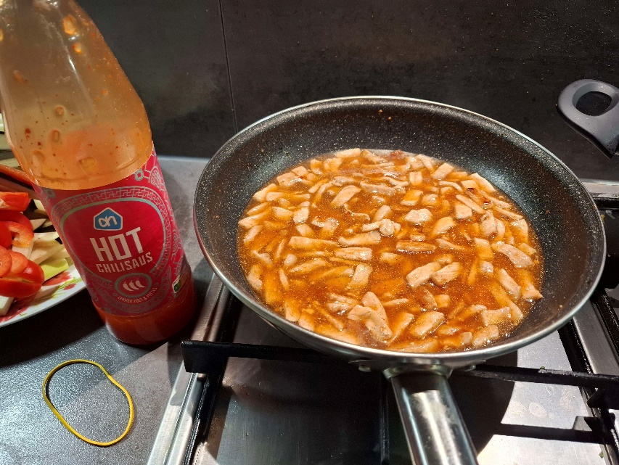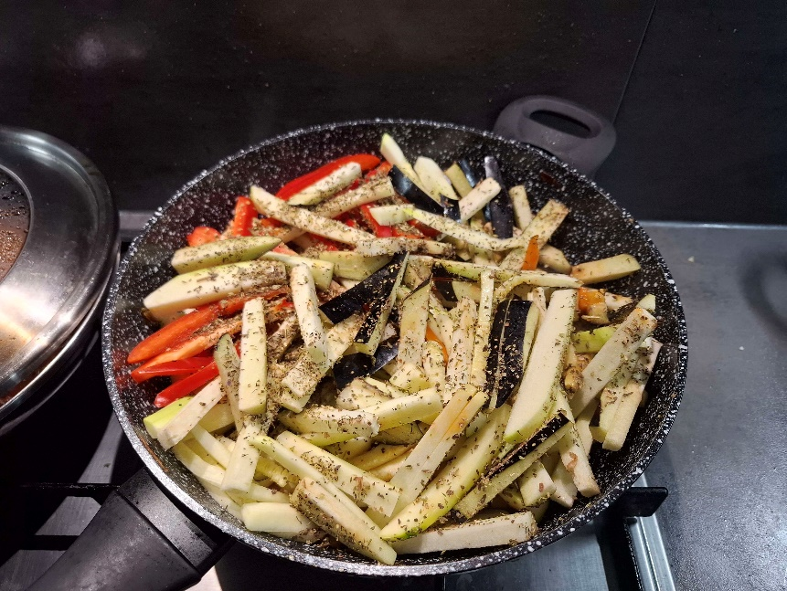

# Green bean soup

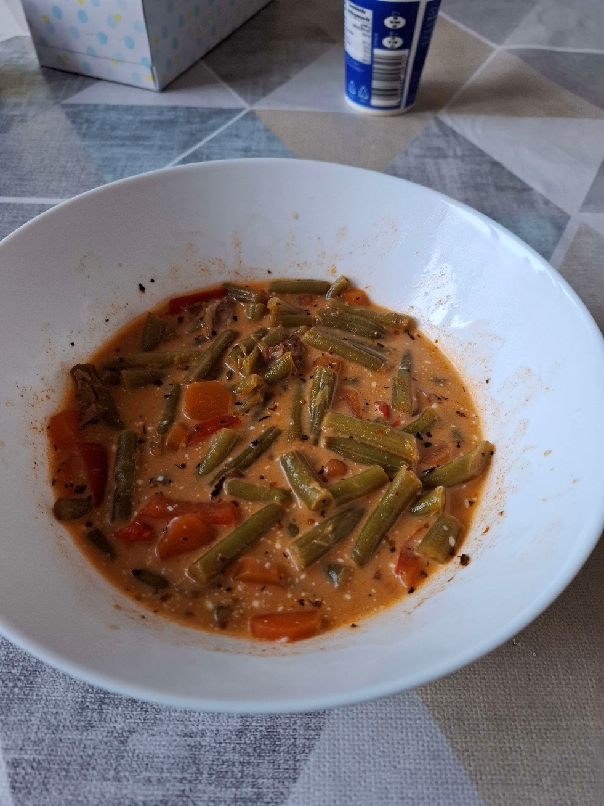

## Ingredients (6 servings)

* 500g of green beans
* 1 small can of tomato concentrate
* Sour cream
* 6 slices of bacon
* 3 carrots
* Garlic
* Sweet paprika powder
* Salt
* Water

## Preparation (1.5 hours)

* Cook the bacon for a few minutes on both sides in a pan and after that cut them into small slices. Also cut all the vegetables
* Put the carrots inside a pot and let them cook for 2 minutes, after that add the garlic that’s been fine crushed trough a press and cook it for about 2 minutes. After that add 0.5L of water and the green beans. Add half of the tomato concentrate and mix them and after add 1.5L more of water and 2 small spoons of salt. Let it boil for about 1 hour and after it’s good to serve
* When it’s on the plate you can add a big spoon of sour cream

## Pictures of the process and finished product

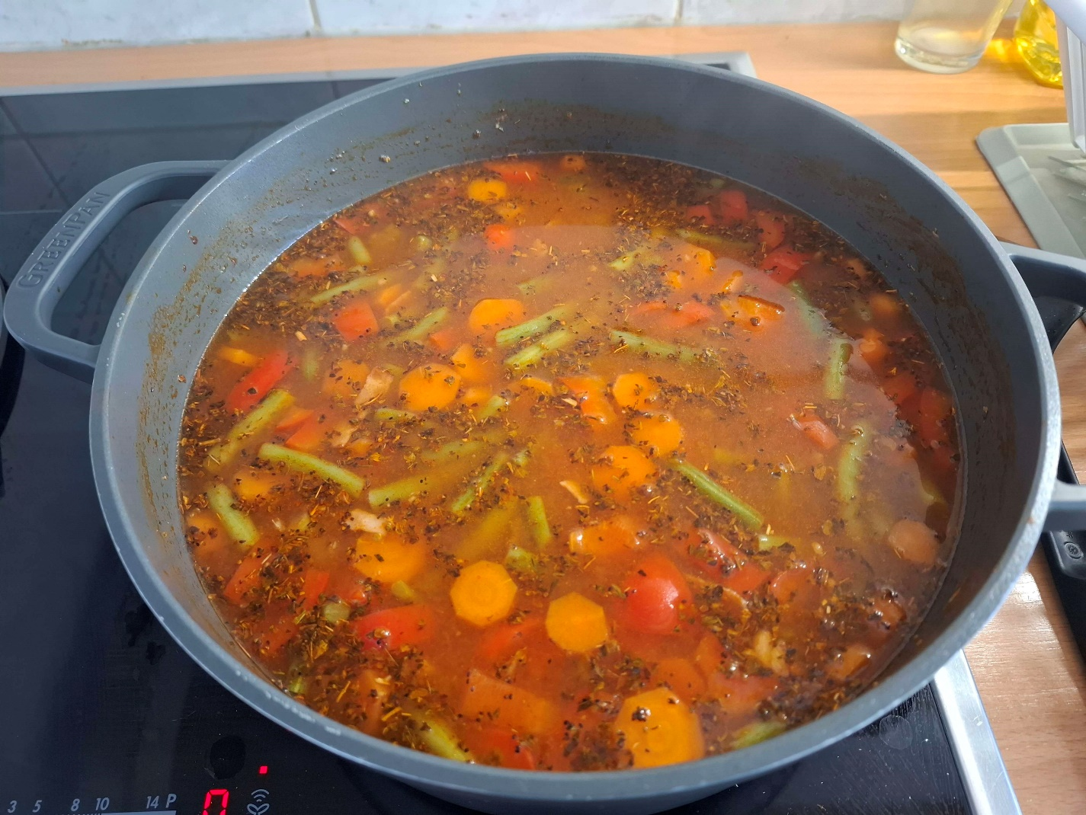

# Brownie-like pastry

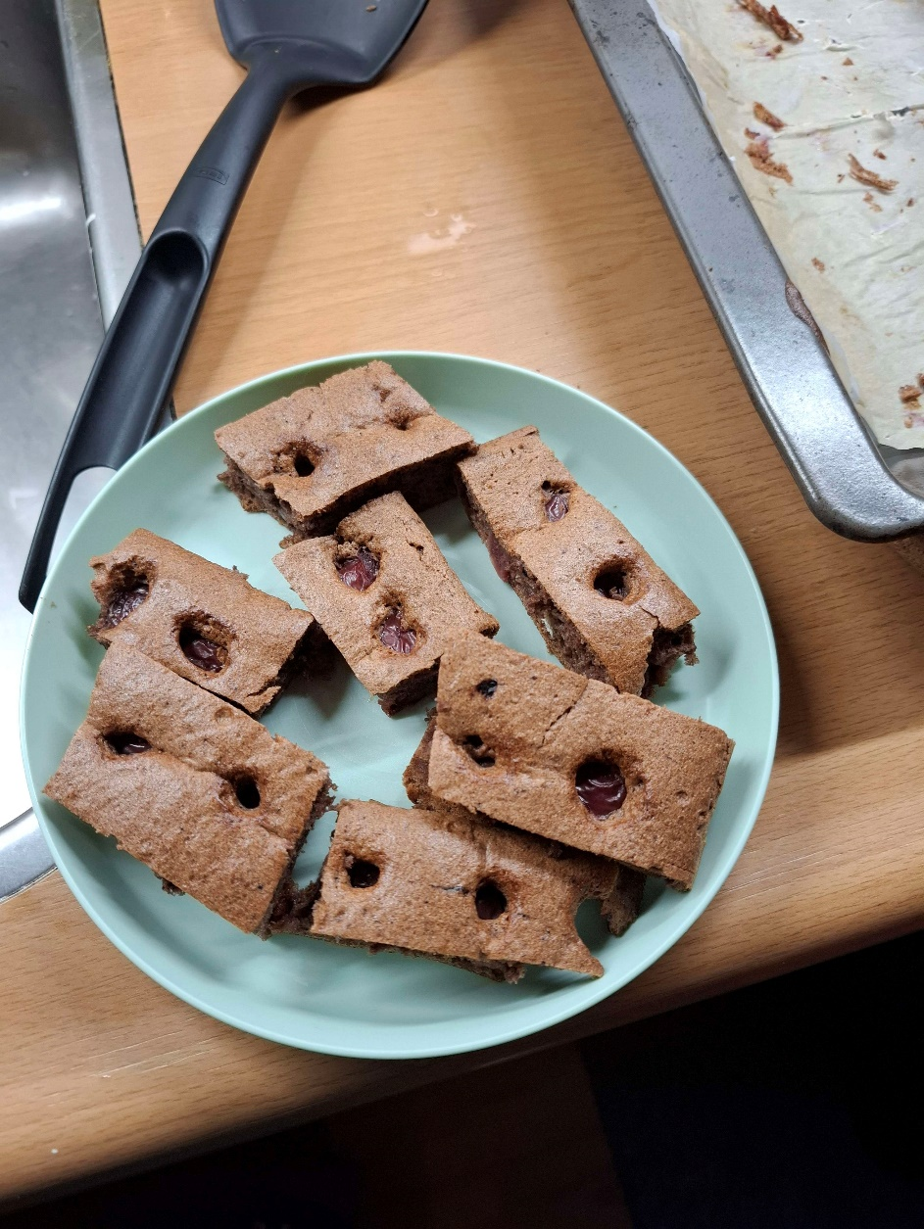

## Ingredients

* 8 eggs
* 7 big spoons of flower
* 1 big spoon of cacao powder
* 8 big spoons of sugar
* 8 big spoons of oil
* 1 small spoon of baking powder
* Half a small spoon of salt
* Vanilla essence
* 1 jar of cherries (you can also use other fruits of your liking)

## Preparation

* Separate the white and the yellow of the eggs. Store the yellows in a dish and put the whites in another big plastic container. Mix the whites with a mixer and keep adding the sugar 1 by 1 spoon and the vanilla essence until the whites have the consistency of a marshmallow
* Place the cherries in a drainer so the liquid drains off them as much as possible
* Mix the yellows with the oil and make it like a mayo
* Slowly add the yellow mix over the whites only 1 spoon at a time and mix it a few times with a wooden spoon slowly before adding the next spoon
* After the yellows are incorporated in the whites start adding the flower 1 spoon at a time and mix slowly making sure everything is mixed before adding another spoon. The last spoon is the cacao powder and mix it well so the whole consistency is brown. Now the mixture is done
* Preheat the oven at 180 degrees and while it heats pour the mixture in an oven tray that has a baking sheet over it. Make sure everything is at the same level and the full tray is filled
* After that slowly add the cherries at equal distances between them all over the mixture as seen in the pictures below
* When the oven is heated put the tray inside and let it bake for around 20 to 25 minutes depending on how roasted you like it

## Pictures of the process and finished product

